1-Emic unit

🧠 What is an Emic Unit?
# Source: AI Source: Provided by: [Data Path: Persons Table -> ID Column: 1, Name_En Column: Motasem Essam] -> From: [Chatgpt (GPT-4-turbo)] on [7/21/2025]
An emic unit is a theoretical or abstract linguistic unit that comes from within the language or culture — based on how native speakers understand and organize their own system.

📘 Definition:
# Source: AI Source: Provided by: [Data Path: Persons Table -> ID Column: 1, Name_En Column: Motasem Essam] -> From: [Chatgpt (GPT-4-turbo)] on [7/21/2025]
An emic unit is a meaningful category or element in a language or culture that is recognized by native users.

🧠 In Linguistics:
# Source: AI Source: Provided by: [Data Path: Persons Table -> ID Column: 1, Name_En Column: Motasem Essam] -> From: [Chatgpt (GPT-4-turbo)] on [7/21/2025]
An emic unit is about function and meaning — how a unit fits into the speaker's system of communication.

Examples in linguistics:
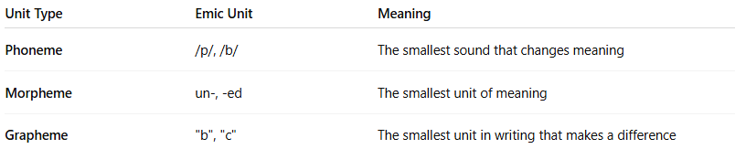

Unit Type | Emic Unit | Meaning
Phoneme | /p/, /b/ | The smallest sound that changes meaning
Morpheme | un-, -ed | The smallest unit of meaning
Grapheme | "b", "c" | The smallest unit in writing that makes a difference
In all cases, the emic unit is what speakers recognize as meaningful or important in their language system.

🔍 "Emic" vs. "Etic":
# Source: AI Source: Provided by: [Data Path: Persons Table -> ID Column: 1, Name_En Column: Motasem Essam] -> From: [Chatgpt (GPT-4-turbo)] on [7/21/2025]


Term | Description
Emic | Insider's view — how speakers understand their own language or culture
Etic | Outsider's view — objective analysis, often by linguists or researchers

Analogy:
# Source: AI Source: Provided by: [Data Path: Persons Table -> ID Column: 1, Name_En Column: Motasem Essam] -> From: [Chatgpt (GPT-4-turbo)] on [7/21/2025]
- Emic = Subjective (internal meaning)
- Etic = Objective (external observation)

✅ Summary:
# Source: AI Source: Provided by: [Data Path: Persons Table -> ID Column: 1, Name_En Column: Motasem Essam] -> From: [Chatgpt (GPT-4-turbo)] on [7/21/2025]
An emic unit is a building block of language or culture that has meaning to the native user — like phonemes, morphemes, or graphemes — and is central to how people interpret and use their own communication system.

2-Etic unit

🌐 What is an Etic Unit?
# Source: AI Source: Provided by: [Data Path: Persons Table -> ID Column: 1, Name_En Column: Motasem Essam] -> From: [Chatgpt (GPT-4-turbo)] on [7/21/2025]
An etic unit is a descriptive, analytical unit used by linguists or researchers to study a language or culture from the outside. It’s based on objective observation, not on the native speaker’s internal understanding.

📘 Definition:
# Source: AI Source: Provided by: [Data Path: Persons Table -> ID Column: 1, Name_En Column: Motasem Essam] -> From: [Chatgpt (GPT-4-turbo)] on [7/21/2025]
An etic unit is an analytical category used by linguists or anthropologists to describe a system (language, sound, behavior) from an external, scientific perspective.

🔍 In Linguistics:
# Source: AI Source: Provided by: [Data Path: Persons Table -> ID Column: 1, Name_En Column: Motasem Essam] -> From: [Chatgpt (GPT-4-turbo)] on [7/21/2025]
An etic unit refers to something you can observe and measure — like the actual sound a person makes, even if it doesn’t carry meaning to the speaker.

Example:
# Source: AI Source: Provided by: [Data Path: Persons Table -> ID Column: 1, Name_En Column: Motasem Essam] -> From: [Chatgpt (GPT-4-turbo)] on [7/21/2025]
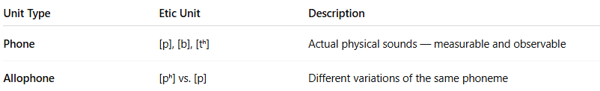
Unit Type | Etic Unit | Description
Phone | [p], [b], [tʰ] | Actual physical sounds — measurable and observable
Allophone | [pʰ] vs. [p] | Different variations of the same phoneme
So, a phone is an etic unit — it's the real sound you hear, even if the speaker doesn’t notice a difference.

🧠 Etic vs. Emic (Side-by-Side):
# Source: AI Source: Provided by: [Data Path: Persons Table -> ID Column: 1, Name_En Column: Motasem Essam] -> From: [Chatgpt (GPT-4-turbo)] on [7/21/2025]
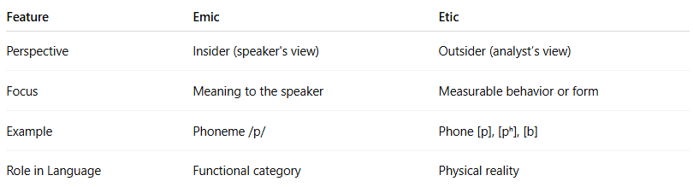

Feature | Emic | Etic
Perspective | Insider (speaker's view) | Outsider (analyst’s view)
Focus | Meaning to the speaker | Measurable behavior or form
Example | Phoneme /p/ | Phone [p], [pʰ], [b]
Role in Language | Functional category | Physical reality

🧪 Real-Life Analogy:
# Source: AI Source: Provided by: [Data Path: Persons Table -> ID Column: 1, Name_En Column: Motasem Essam] -> From: [Chatgpt (GPT-4-turbo)] on [7/21/2025]
- Emic: A native speaker knows that /t/ and /d/ are different because they change meaning.
- Etic: A phonetician notices that the /t/ in “top” is aspirated ([tʰ]) and in “stop” is unaspirated ([t]) — even though native speakers don’t think they’re different.

✅ Summary:
# Source: AI Source: Provided by: [Data Path: Persons Table -> ID Column: 1, Name_En Column: Motasem Essam] -> From: [Chatgpt (GPT-4-turbo)] on [7/21/2025]
An etic unit is an objective, scientific description of a sound or structure that may not be meaningful to native speakers — but is important for linguistic analysis and comparison.

